**Create an ARM Assembly Language Program**

To create an assembly language program, you need to use a text editor such as **NotePad** in Microsoft Windows environment. There is a text edit in the Keil uVision4 for you to use. The file name must have a **.s** at the end. Let's look at the following program called **MyFirstArm.s** on a PC. The file **MyFirstArm.s** contains the source code of the program to load registers and demonstrate a few other operations. We will use Keil uVision4 to create a project and execute this program so that you can get a feel of how Keil uVision4 works.

;The semicolon is used to lead an inline documentation

;This is the first ARM Assembly language program you see in the lab

;This program skeleton is from Dave Duguid and Trevor Douglas in summer 2013.

;When you write your program, you could have your info at the top document block

;For Example: Your Name, Student Number, what the program is for, and what it does etc.

;;; Directives

PRESERVE8

THUMB

; Vector Table Mapped to Address 0 at Reset

; Linker requires __Vectors to be exported

AREA RESET, DATA, READONLY

EXPORT __Vectors

__Vectors

DCD 0x20001000 ; stack pointer value when stack is empty

DCD Reset_Handler ; reset vector

ALIGN

; The program

; Linker requires Reset_Handler

AREA MYCODE, CODE, READONLY

ENTRY

EXPORT Reset_Handler

Reset_Handler

;;;;;;;;;;User Code Starts from the next line;;;;;;;;;;;;

MOV R0, #12

STOP

ADD R0, R0, #4

B STOP

END ;End of the program

References:

1. [**A complete list of DIRECTIVES**](http://infocenter.arm.com/help/index.jsp?topic=/com.arm.doc.dui0489c/Cacigaci.html)from ARM Information Center
2. [**Cortex-M3 Devices Generic User Guide**](http://infocenter.arm.com/help/topic/com.arm.doc.dui0552a/DUI0552A_cortex_m3_dgug.pdf)

**Start up Keil uVision4**

Before you start up, you are recommended that you create a folder to hold all your project files.   
For example: you can have a folder "FirstARM-Project" ready before hand.

You can start up **uVision4** by clicking on the icon  from the desktop or from the "Start" menu or "All Programs" on a lab PC.   
The following screen is what you will see.

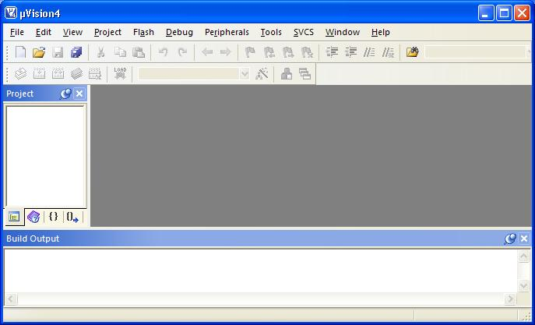

**Create a project**

Let's create our firt ARM **uVision4** project now. To create a project, click on the "Project" menu from the **uVision4** screen and select "New uVision Project...".   
 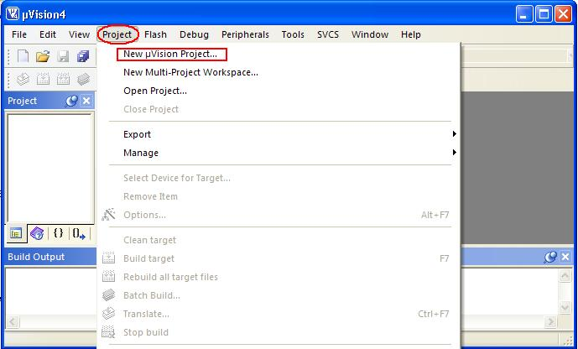

Then, select a folder, give project a name and save.   
 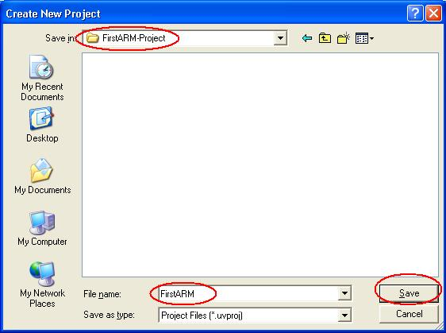

From the "Select Device for Target" window, select "STMicroelectronics" as the vendor.

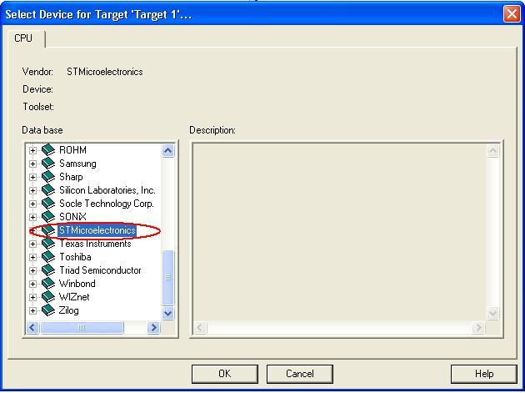

click on "+" beside "STMicroelectronics" and then select "STM32F100RB" and click on "OK".

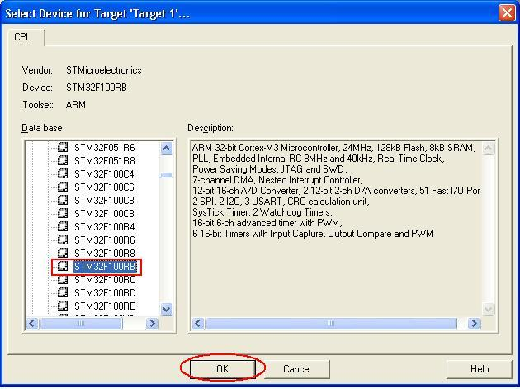

Make sure you click on "NO" for the following pop up window.

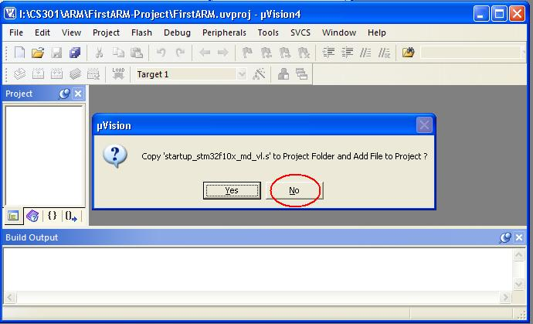

**Create Source File**

From the "File" menu, select "New", you will see the "Text1*" text edit window. That is the place you will write your ARM Assembly language program. For a test, you can copy and paste the example program into this window.

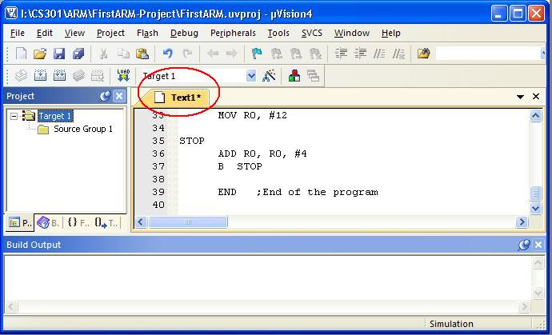

Save the program by clicking on the "Save" or "Save As" from the "File" menu and give it a name.

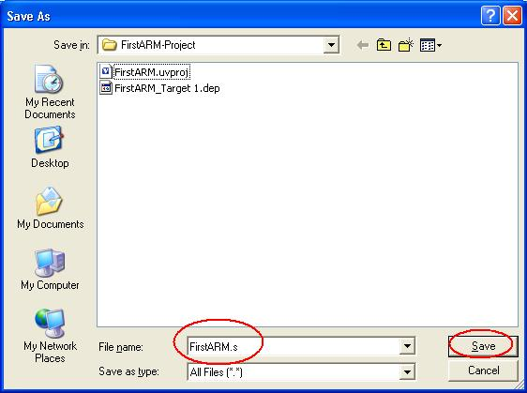

**Add Source File to the Project**

Right click on the "Source Group 1", select "Add Files to Group 'Source Group 1'".

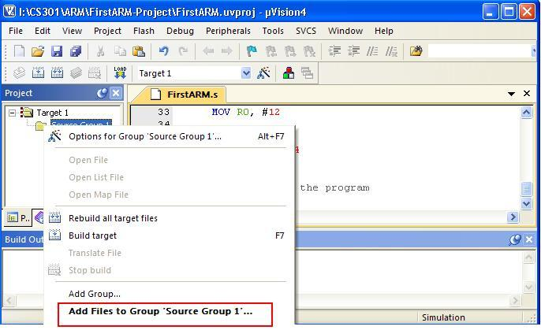

Select "Files of type" as "Asm Source file (*.s*;*.src*;*.a*), then select the file "FirstARM.s" for example.   
Click on "Add", and then click on "Close".

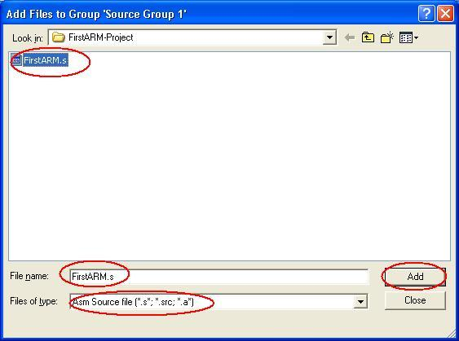

**Build your project**

Click on the "+" besid the "Source Group 1", you will see the program "FirstARM.s".   
Click on the "Build" button or from the "Project" menu, you will see the following screen.

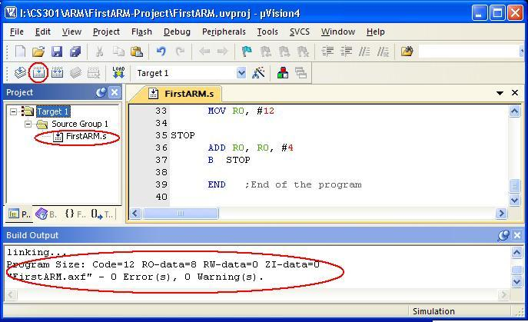

**Run the program in your project**

The assembler is happy with the program. We can now run the program through "Debug" menu.

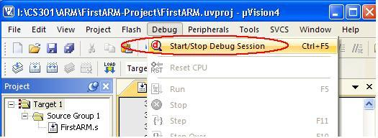   
Click on "OK" for the pop up window showing "EVALUATION MODE, Running with Code Size Limit: 32K".

Open your uVision4 to full screen to have a better and complete view. The left hand side window shows you the registers and the right side window shows the program code. There are some other windows open. You may adjust the size of them to see better.   
Run the program step by step, you can observe the change of the values in the registers.

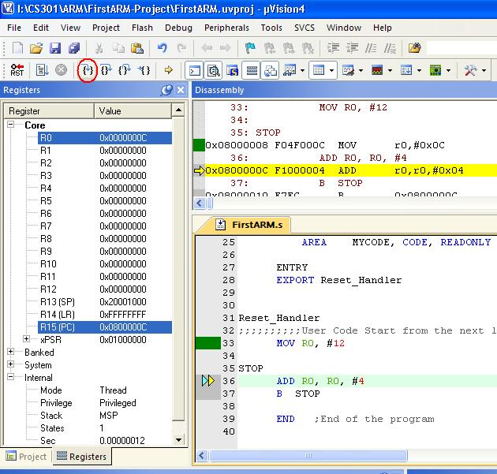

Click on the "Start/Stop Debug Session" again to stop executing the program.